**Automation Team Scripts Running Process SOP**

Hot Fix Release Versions:

|  |  |
| --- | --- |
| **Product** | **URL used** |
| 2020 R2 Stable | 1.78 |
| 2022 | 1.68 |
| 2024(Demo Setup) | 1.106 |

**Receive any Hot Fix mail from Build Team / Test Managers:**

1. Need to Restore All Automation DB’s to DBA team.
2. Need to ask DBA team to Run DB sync For AutomationPoliceMJ, AutomationPoliceNJ and AutomationFireMJ and AutomationIA DB once after restoring all Automation dbs.
3. Need to Take all Automation DBs backup.
4. Run Precompile for Police, Fire, IA, and CRM.,
5. Connecting Nodes (VM)/(Local) to the HUB (M/C running scripts).
6. Start To run Smoke Test scripts from Eclipse for Police, Fire, IA and CRM.
7. Start To run EntrySmoke Scripts for Police, Fire and IA (It needs to be done as Teamwork).
8. Start To run Functional Scripts for All the Modules from Eclipse.
9. Start To run Defect Scripts from Eclipse.
10. Start to run Traffic and Report Entry scripts for AutomationPoliceNJ DB.,
11. Check KS, WI, MN, and MA DB Traffic Modules.
12. Review failed scripts
13. Send Report to respected Team on next 24hrs.

**Repackage Mail: 2020/2020 R2:**

Receive any Repackage mail from Build Team / Test Managers.

1. Restore All Automation DB’s
2. Run DB sync For AutomationPoliceMJ, AutomationPoliceNJ and AutomationFireMJ, AutomationIA DB. (If needed)
3. Take backup if ran DB sync.
4. Run Precompile for repackaged RMS
5. Connecting Nodes (VM)/(Local) to the HUB (M/C running scripts).
6. Start To run Smoke Test scripts from Eclipse for Police, Fire, IA and CRM.
7. Start To run EntrySmoke Scripts for Police, Fire and IA (It needs to be done as Teamwork).
8. Start To run Eclipse and Selenium IDE Scripts (Reports, Records and Property Related Testcases)
9. Review failed scripts
10. Send Report to respected Team on same Day (receive Mail before 5PM)
11. Check previous issues are replicated

**Demo Setup Mail:**

Receive any Repackage mail from Build Team / Test Managers.

1. Need to Ask DB team to Restore Automation DB’s (AutomationPoliceMJ, AutomationPoliceNJ and AutomationFireMJ and AutomationIA DB)
2. Need to ask DBA team to Run DB sync For AutomationPoliceMJ, AutomationPoliceNJ and AutomationFireMJ and AutomationIA DB once after restoring all Automation dbs.
3. Need to Take all Automation DBs backup.
4. Run Precompile for Police, Fire, IA
5. Connecting Nodes (VM)/(Local) to the HUB (M/C running scripts).
6. Start To run Smoke Test scripts from Eclipse for Police, Fire, IA, and CRM.
7. Start To run EntrySmoke Scripts for Police, Fire, and IA (It needs to be done as Teamwork).
8. Start To run Functional Scripts for All the Modules from Eclipse.
9. Start To run Eclipse and Selenium IDE Scripts (Reports, Records and Property Related Testcases)
10. Review failed scripts
11. Send Report to respected Team on same Day.

**Pre-Requisite for running Scripts**

**STEPS TO LAUNCH HUB:**

1. In Desktop we will have a Folder in the name of “GridConfiguration”
2. Locate the HubStart.bat file in GridConfiguration folder (Refer Screenshot)

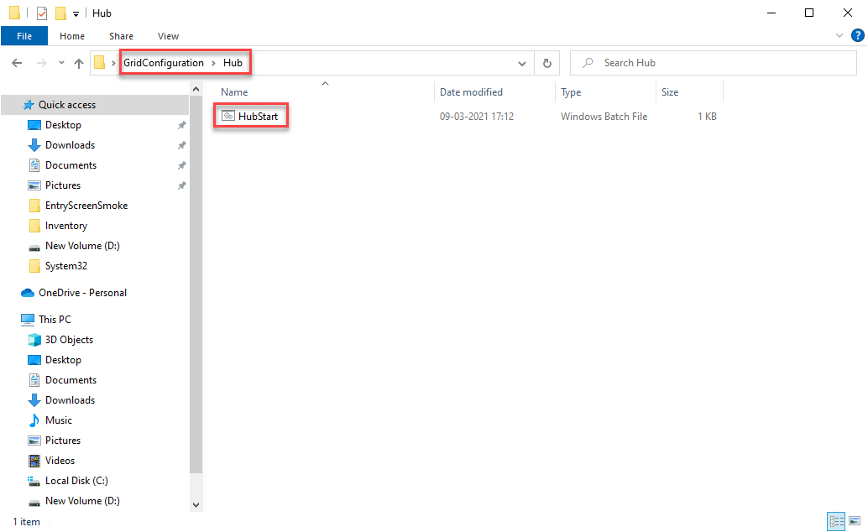

1. Double click on HubStart.bat file
2. After launching HubStart.bat In Console you can check it relates to your Hub IP with Default Port (4444)

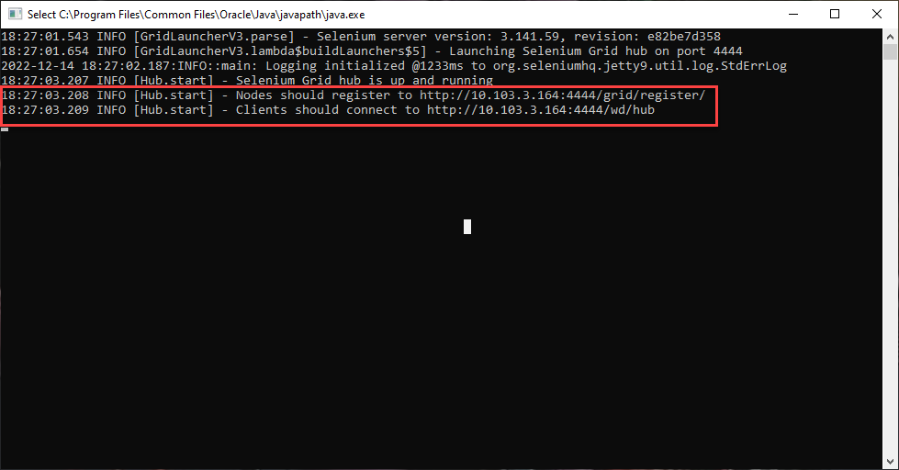

**STEPS TO LAUNCH NODES:**

1. In the same GridConfiguration folder we can see “Nodes” folder, inside that we are having multiple nodes (Node1, Node2, Node3)

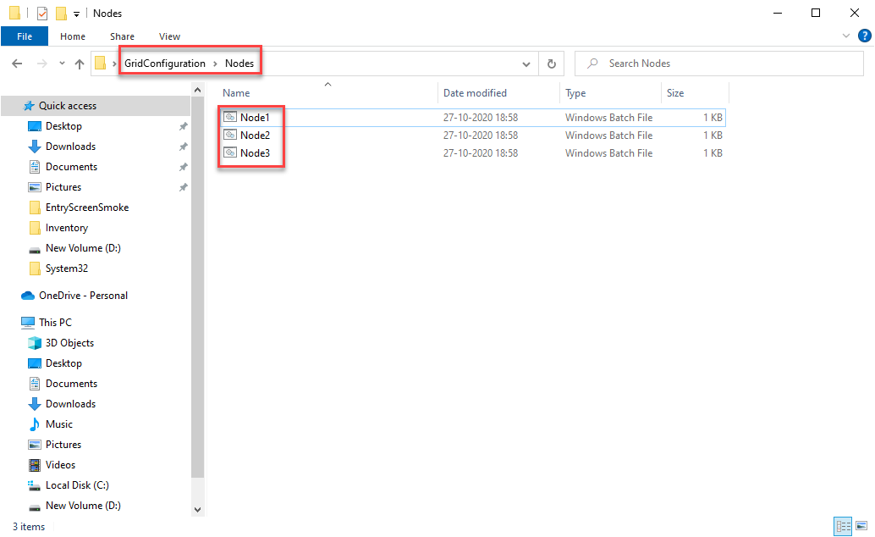

1. Connect Maximum of 3 Nodes to run Suite Files at the time of HotFix
2. (e.g.,) Double click on Node1.bat
3. After launching Node1.bat In Console you can check it relates to your Hub IP and Node Port (2223) which we mentioned in Node1.bat

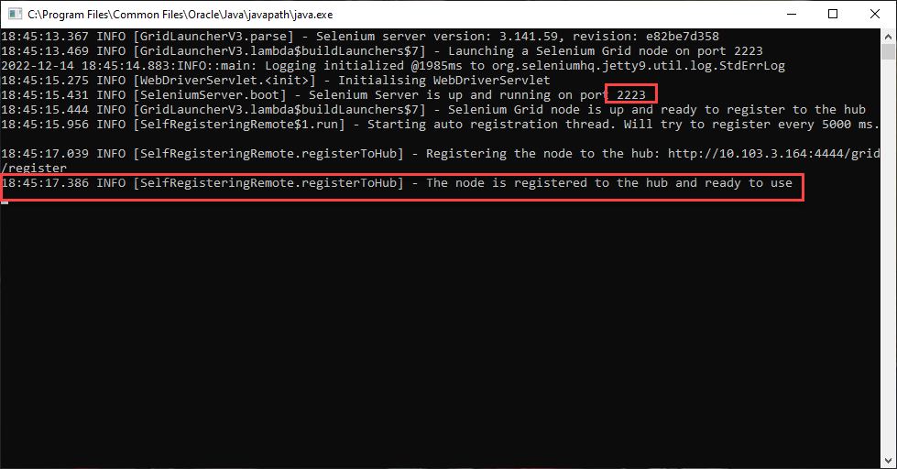

**VERIFICATION OF HUB & NODES:**

1. After launching both Hub and Nodes you can check in Hub Console, Node port will get connected to the Hub.

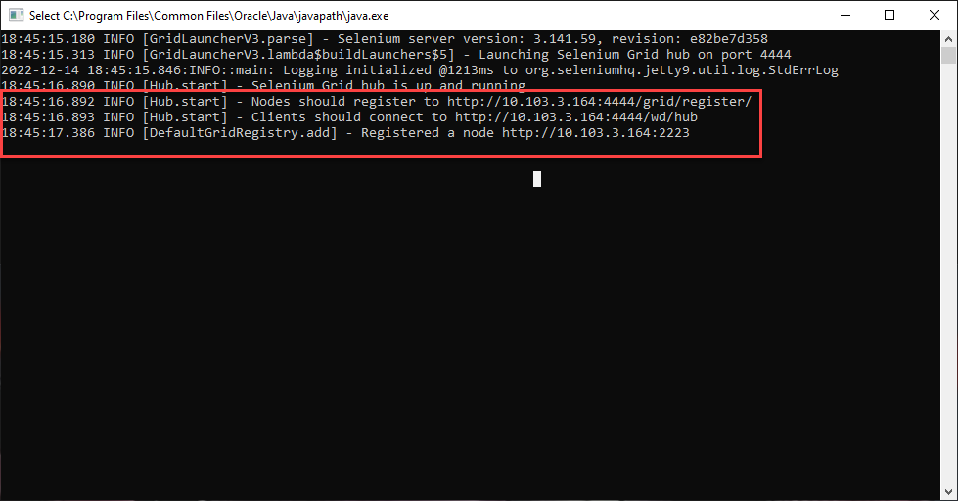

1. Once after this confirmation, you can start running Suite Files in Eclipse

**Note: If you connected 3 Nodes with 1 Hub Maximum of 3 Suite Files we can queue at a time.**

**Happy Testing…!!!**